Cloud Computing
UE19CS352
6th Semester, Academic Year 2021-22
Experment #: 5 – AWS IAM
Date: 18/4/2022
Name :  SUMUKH RAJU BHAT | SRN :  PES1UG19CS519 | Section :  H

1a.png:
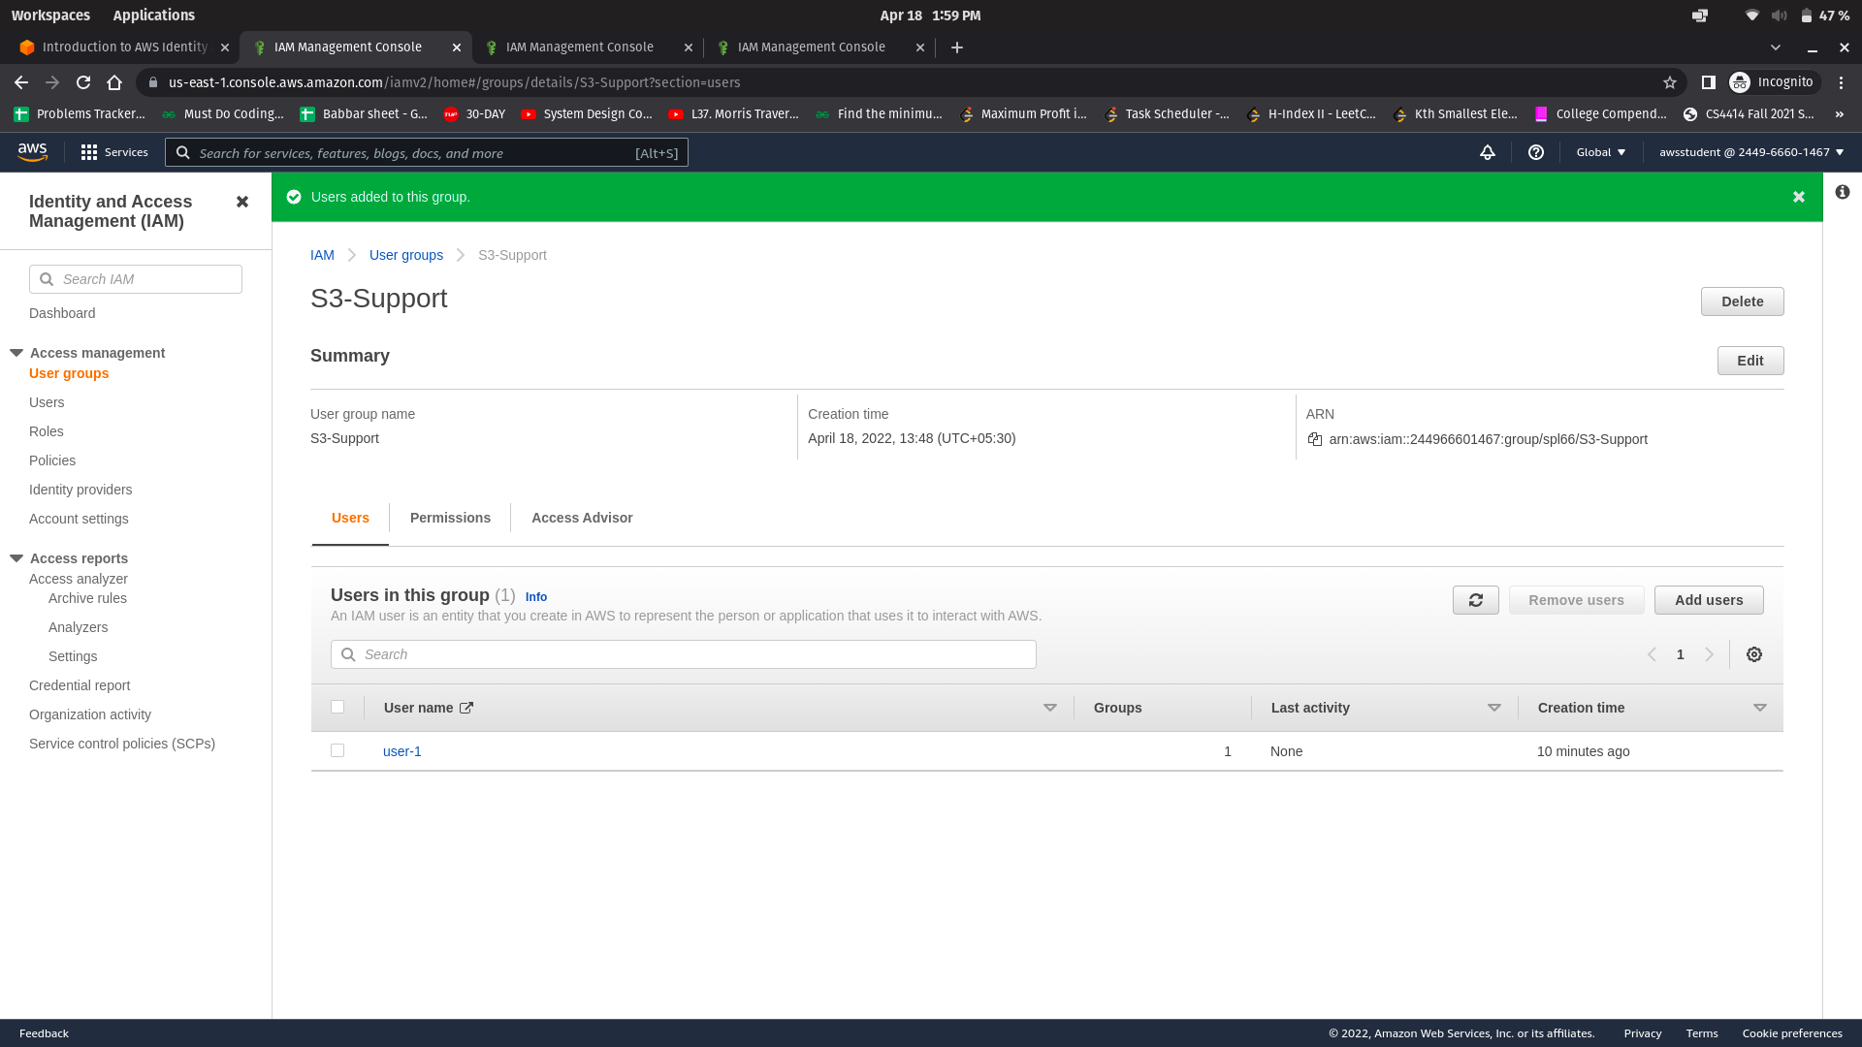
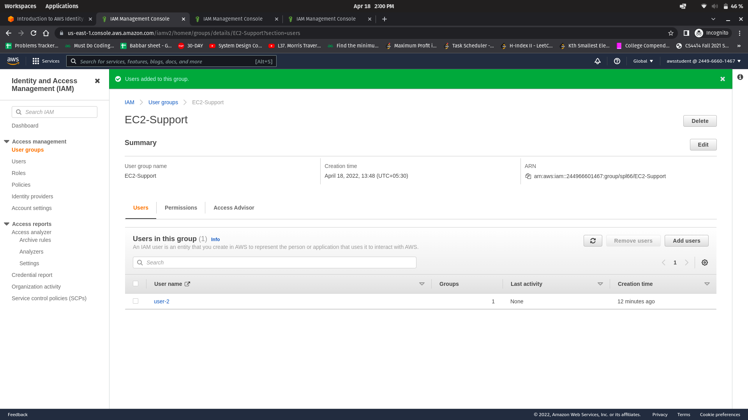
1b.png:

1c.png:
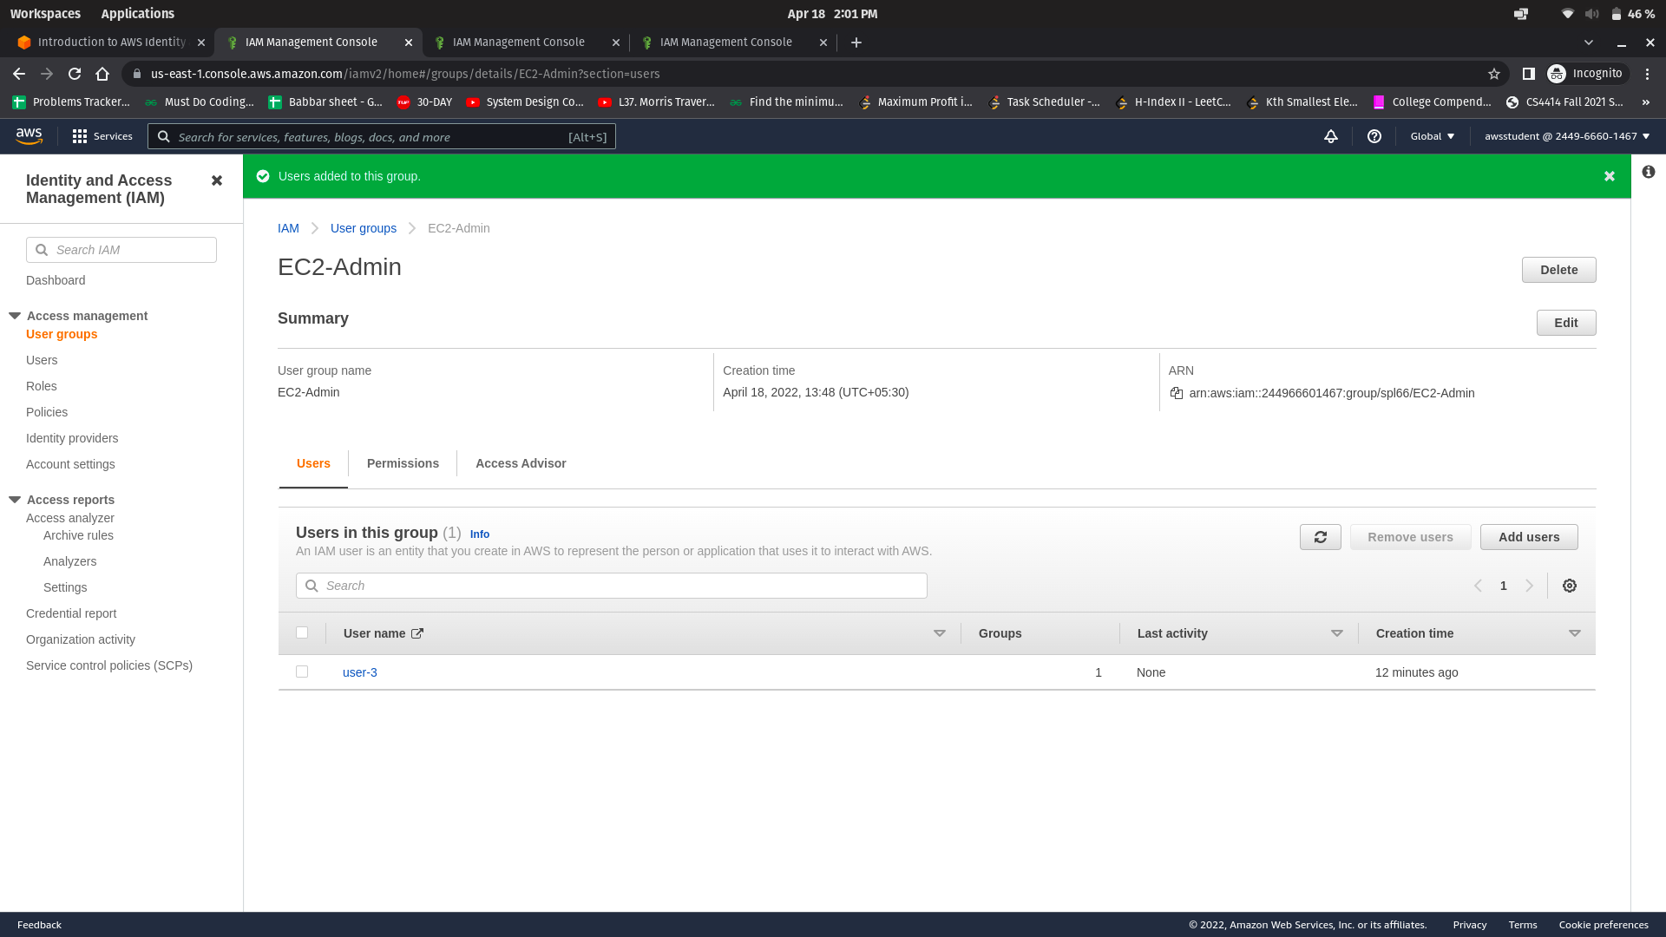
2a.png:
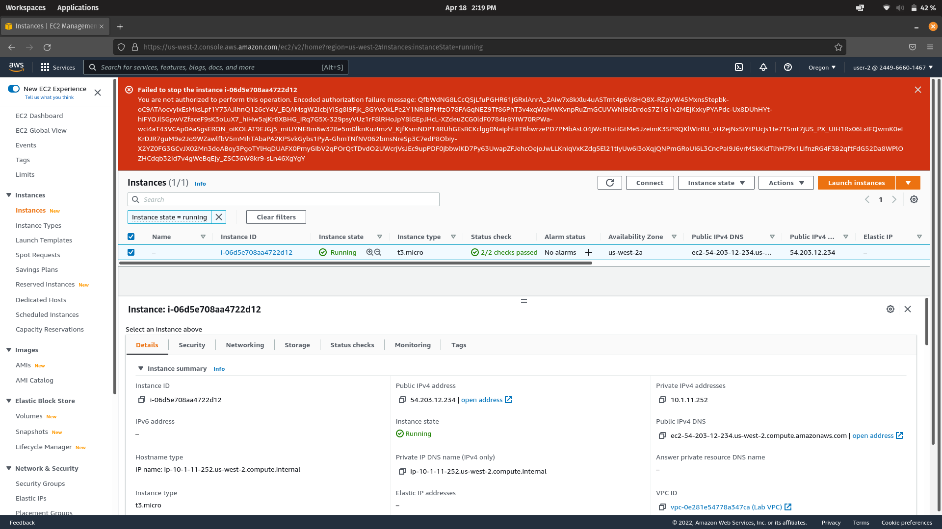
2b.png:
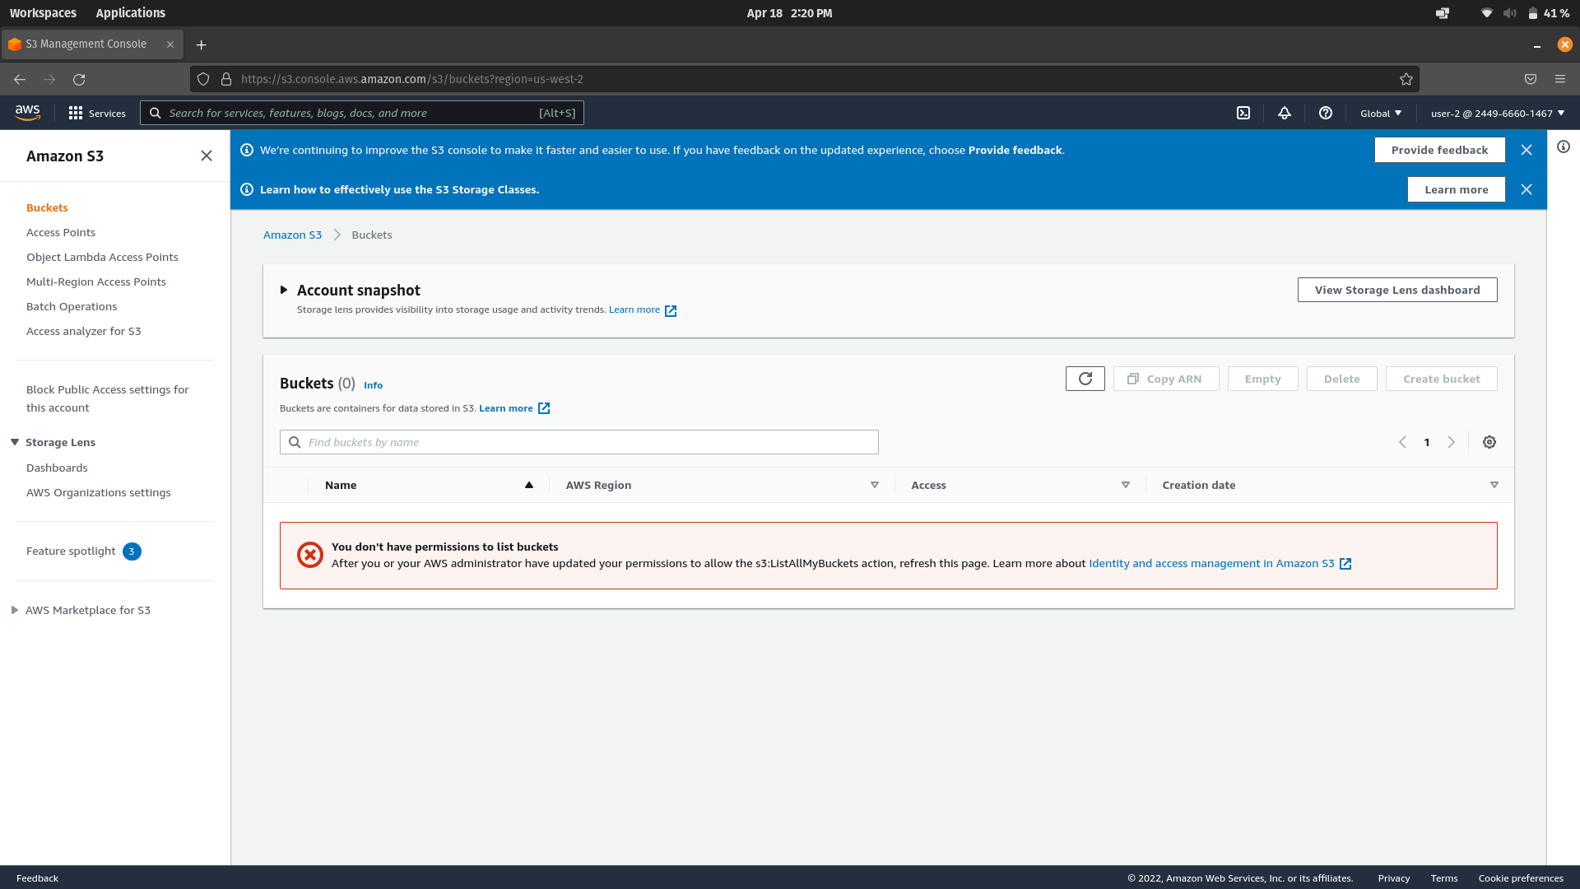
2c.png:
